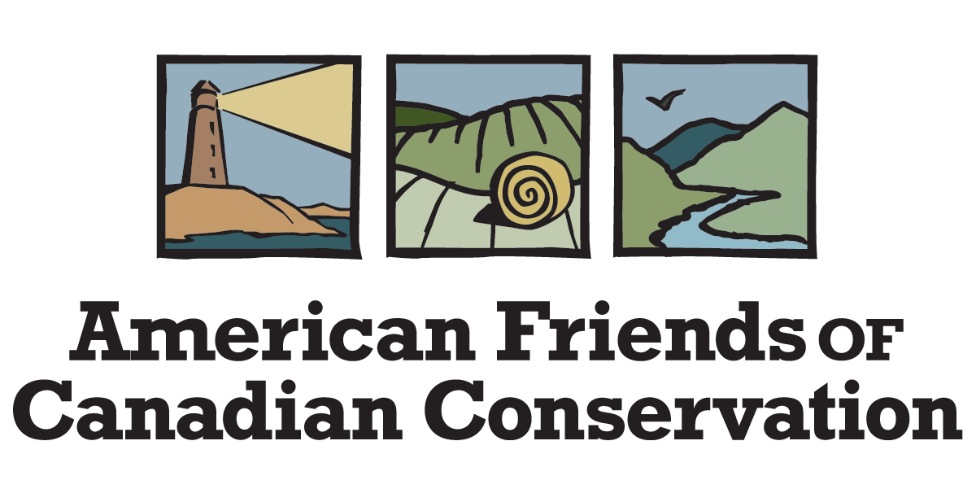

Grantee Application

Updated October 2023
GRANTEE APPLICATION CHECKLIST
Thank you for your interest in becoming a Grantee of American Friends of Canadian Conservation (AFCC) so that we can work together to increase funding and land conservation in your part of Canada.
This Grantee Application Checklist has two parts. Complete only Part I if your organization wants to be a “Cash Grantee” - eligible to receive financial grants through AFCC’s General Support Program. Complete Parts I and II if your organization wants to be a Land Grantee - eligible to receive gifts of land (or partial interest in land such as easements, covenants, servitudes, and remainder interests) through AFCC’s Conservation Lands Program. Your organization can be both a Cash and Land Grantee, the only difference is the cost of applying and renewing annually. The fees are listed at the bottom of this page.
For more information on AFCC, please visit https://conservecanada.org or contact Caitlin Strasser, Administrative and Finance Associate, at (360) 378-7305, caitlin.strasser@conservecanada.org.
We recognize that becoming an AFCC Grantee is an exacting process. This level of evaluation is necessary to comply with US Internal Revenue Service (IRS) requirements. AF’s ability to accept tax deductible gifts from US taxpayers is the key to its role in Canadian conservation. So it is imperative that we follow IRS guidelines. In addition, our careful evaluation of potential partners allows AFCC to assure donors that grantees are qualified, well-run Canadian conservation entities.
To apply to become a Grantee
Please complete the following forms and send them either electronically or in paper form, together with any required documents:
All Grantee Applicants:
Part I - Completed Application plus:
  - Organization’s registration, incorporation and other governance documents,
  - Organization’s bylaws
  - Documentation verifying charitable status in Canada
  - Organizational budget and financial statement
  - List of Board of Directors, Senior Advisors and Staff
  - Signed Grant Agreement
  - Grantee Initiation Fee *
General Support Program Only (for cash grants): $350 USD
Conservation Land Program Only (for land/easement grants)-$500 USD
Grantee for both programs: $800 USD
Additional requirements for Grantees that want to also be eligible to receive donations of land/interest in land
Part II – Completed Application plus:

For grantees anticipating transfers of conservation easements from AFCC, copy of IRS ruling letter verifying status as equivalent to a publicly supported charity, not a private foundation (Please refer to Fact Sheet on Applying for Public Charity Status available in the Resources section of https://conservecanada.org)

Copy of Board resolution adopting Canadian Land Trust Standards and Practices (if applicable)

Copy of documentation verifying organization is eligible under the federal Ecological Gifts program to receive Ecological Gifts (if applicable)

Please send your completed application to:

American Friends of Canadian Conservation
336 36th St., #717
Bellingham, Washington 98225 USA

Or send digital documents to caitlin.strasser@conservecanada.org

For questions or assistance please call Caitlin Strasser, Administrative and Finance Associate, (360) 378-7305

* There is a modest annual renewal fee to maintain your organization’s grantee status with AFCC as follows: $150 USD for General Support Program, $250 USD for Conservation Lands Program, or $300 USD for both programs

Part I

GRANTEE APPLICATION FORM
Please answer the following questions so that we may determine whether your organization meets the grantee selection criteria. In order to achieve our mission and goals, and maintain our favorable tax status in both the U.S. and Canada, American Friends of Canadian Conservation uses these metrics to evaluate applications for Grantee status.
Your answers will not automatically qualify or disqualify your organization.
Name of Organization:
Type of Grantee? (Cash, Land, or Both)
Mailing Address:
Telephone:
Fax:
Email:
Contact:
Title:
Please give a brief description of your organization and its current activities (100 words maximum please):

- Is the purpose of the organization conservation and protection of land,
or is this one of the primary activities of your organization?
Yes No
- Is your organization a government or quasi-government entity?
Yes No
- Is your organization operated exclusively for charitable purposes?
Yes No
If yes, please provide a copy of documentation verifying charitable or other status (e.g. non-profit).
- Has your organization adopted the Canadian Land Trust Standards and Practices ?
Yes No
If yes, please provide a copy of Board resolution adopting the Standards and Practices
- Is your organization organized as a corporation?
Yes No
If yes, please provide a copy of your organization's registration documents, incorporation papers or other governance and tax exemption documents.
If no, what is the form of your organization?
- Does your organization carry out lobbying activities, or attempt to influence legislation? Yes No
If yes, briefly describe these activities and estimate the proportion of time/budget allocated to such activities:
- Does your organization attempt to influence the outcome of political campaigns by candidates for public office? Yes No

If yes, briefly describe these activities and estimate the proportion of time/budget allocated to such activities:
- Is your organization required by law to apply its profits (revenues in excess of expenses) to the furtherance of its stated purposes?
Yes No
- Does any part of the assets or your organization, now or planned for the future, inure to the benefit of private individuals, other than in the form of services that your organization is authorized to provide and is fairly compensated for?
Yes No
If yes, please explain:
- Does your organization make any payments to any of its officers or members of its Board of Directors or other governing body, other than reasonable compensation for services to the organization, including reimbursement for expenses? Yes No
If yes, please explain:
- Upon dissolution, must your organization’s assets be distributed for charitable and conservation purposes?
Yes No
- Is your organization controlled by or operated in connection with any other organization?

Yes No

If yes, please list the names of such organizations and the nature of such control or connection:
- What is the estimated annual amount of cash or cash equivalent (i.e. donations of stock etc.) you expect to be donated to the AFCC on an annual basis from donors who are interested in supporting your activities? ______________________________.
- Please provide a list of the use(s) to which any funds received will be put (e.g., support of land conservation activities conducted in Canada)
- Please provide an organizational budget and financial statement (balance sheet and income/expense statements).
- Please provide a list of Board of Directors, Senior Advisors and Senior Staff
The undersigned officer or authorized representative of the organization affirms that the foregoing statements are complete and accurate:

Organization Name

Name of Officer or Representative Title

Signature of Officer or Representative Date

OFFICIAL SEAL OR STAMP:

Grant Agreement

If your organization is approved as a Cash Grantee of American Friends of Canadian Conservation (AFCC), all grants will be subject to certain conditions. Please review the conditions outlined below and indicate that your organization agrees to the following terms and conditions by signing and returning this form with your application.
- Grants must be used exclusively for land conservation activities conducted within Canada.
- Any portion of a Grant not used for the stated purpose must be repaid to AFCC.
- Your organization agrees to submit an annual report to AFCC describing the use of the funds and activities undertaken as a result grants made in the prior year.
- Your organization agrees that it shall not use any portion of a Grant to make grants to individuals, nor for any non-charitable or non-educational purpose. It shall not use funds to participate in or intervene in (including the publishing or distribution of statements) any campaign on behalf of (or in opposition to) any candidate for public office; or fund any specific voter registration drive that that favors a particular political candidate or slate of candidates. It shall not knowingly permit any portion of a Grant to be used to promote or support violence or terrorism.
- Your organization agrees to notify AFCC immediately, in writing, of any change in its charitable status, its executive staff or key staff, or any other major changes in its program. If a fiscal sponsorship is involved, your organization will promptly notify AFCC of any changes in the sponsorship agreement or in the sponsor/project relationship.
- All expenditures made for the purposes of a Grant shall appear in your organization’s financial records, which will be made available to AFCC at reasonable times upon request.

Please note, accepting the above terms and conditions does not guarantee that any Grant will be awarded.
IN WITNESS WHEREOF, this Grant Agreement is signed
Organization Name
Name of Officer or Representative Title
Signature of Officer or Representative Date
Part II
If your organization wants to partner with AFCC to secure donations of land, easements/covenants or other partial interests from U.S. taxpayers, please complete the remaining questions in addition to the questions in Part I.

Please note: In collaboration with Canadian conservation organizations, American Friends of Canadian Conservation (AFCC) conserves significant Canadian natural lands owned by US taxpayers. As a small and efficient charitable organization AFCC must be very strategic in its choice of projects. Accordingly, AF seeks to partner in the protection of properties that are high priorities for its Grantees. It is important that AFCC’s Canadian partners are thoroughly acquainted with the area and the specific tract proposed for protection. Only properties with marketable title that are free of liability concerns can be accepted by AFCC.

To keep AFCC’s expenses low, Grantees are responsible for completing all land procurement, stewardship and management activities even though the gift will be made to AFCC. All costs related to both procurement and stewardship are the responsibility of the Canadian conservation organization and/or donor.

AFCC's mission is best served by conveying conservation lands and easements it receives from US residents to qualified conservation organizations in Canada. However, the tax deductibility of donations made to AFCC would be jeopardized by any advance guarantees made with respect to AFCC’s disposition of properties given to it. To protect donors' potential charitable deductions for their gift of land or partial interest in land, AFCC structures its land acquisitions and dispositions as two entirely separate processes.

The Board is grateful for your interest in AFCC and patience with the complexities of cross border conservation projects. We appreciate all you do to conserve Canada's natural resources.
- Is your organization eligible to receive Ecological Gifts under the
Federal Ecological Gifts Program?
Yes No
If yes, please provide a copy of documentation verifying that the organization is eligible under the federal Ecological Gifts program to receive ecological gifts.
- Has your organization adopted the Canadian land trust standards and practices?
Yes No
- Do you have a ruling letter from the IRS stating your status as a publicly-funded charity as opposed to a private foundation?
Yes No
If yes, please submit a copy of your IRS ruling letter. See the AFCC Factsheet on becoming a publicly supported charity. Available at https://conservecanada.org.
Please note—IRS recognition is required only if a Grantee wants to be eligible to receive transfers of partial interest in land from AFCC, such as easements/covenants. It is not required for cash grants from AFCC, or transfers of land from AFCC, but is recommended for all Grantees. The application can be made after an organization is approved as a Grantee. See Fact Sheet on Applying for Public Charity Status in the Resources section of AFCC’s website for more information on the application process and benefits.
- Please describe the staff/volunteer/Board resources available to your organization to support land acquisition and stewardship.
- Please describe your organization’s land stewardship program and capacity. Use specific examples of your current stewardship projects, programs and policies.
- Please provide a brief description of your organization’s background by filling in the boxes that follow, or provide the information in an attachment:
Mission statement:

History of protecting conservation lands
Portfolio of conservation properties

Annual conservation budget

Stewardship fund amount, and polices that govern use of the funds
Key land conservation activities and programs (Strategic Plan)

Is there anything else that you would like to share with AFCC about your organization that may be relevant?

